Practice Assignment 1
Scatter Plots, Correlation, and Linear Regression
  - Discussion on Wednesday, May 6th at 4 PM
This practice assignment will use the Country_Information.csv file on GitHub. In this data set, some variables were collected from 41 countries around the world. The variables in the data set are
- Life expectancy (LifeExpectancy),
- Average number of years of schooling (YearsSchool),
- Gross domestic product per capita (GDP) in U.S. dollars,
- The gender inequality index (GII), which rates the amount of gender inequality in the given country (bigger values mean more inequality),
- An index score rating the quality of education in the given country (EduIndex), and
- Public health expenditures, which measures how much the given country spends on public health programs (PubHealthExp).

- Read the dataset into R. Also, if you have not already, install the math3150package library from my GitHub (instructions for this are in the notes) and load that package. This will also load the tidyverse.
Done!
- Create a correlation matrix with all of the variables except country and include the correlation matrix here. A screenshot or copy and paste is fine. Feel free to round the correlations to 3 decimal places. You can do this with the cor() function.
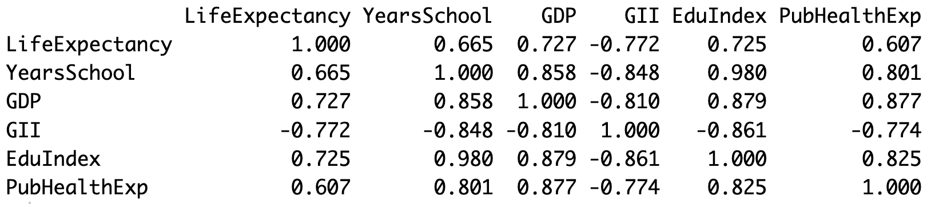
  - Which two variables have the strongest linear relationship? Explain briefly how you know.
We find the correlation in the matrix closest to -1 or 1 (aside from the values of 1.000 in the diagonals) is 0.980. The variables that correlation corresponds to are Education Index and Years of School since those are the variables in the row and column of the 0.980.
  - Which two variables have the weakest linear relationship? Explain briefly how you know.
The correlation closest to zero in the matrix is 0.607, which is for Life Expectancy and Public Health Expenditures.
  - Suppose you want to predict life expectancy. Which other variable would be most useful in predicting performance? Note that you cannot use life expectancy to predict itself.
The most useful would be the one that has the highest correlation with Life Expectancy. That is GII with a correlation of -0.772.
  - Which variable would be least useful in predicting life expectancy?
This would be the one with the lowest correlation with Life Expectancy. That is Public Health Expenditures with a correlation of 0.607.
- Fit a linear regression model using GII as the explanatory variable and life expectancy as the response variable.
  - Using ggplot, make a scatterplot of life expectancy (on the y-axis) against GII (on the x-axis). In addition, include the line of best fit by adding this line of code to your ggplot:
geom_smooth(method = "lm", formula = "y ~ x", se = F)
Include the scatterplot here.
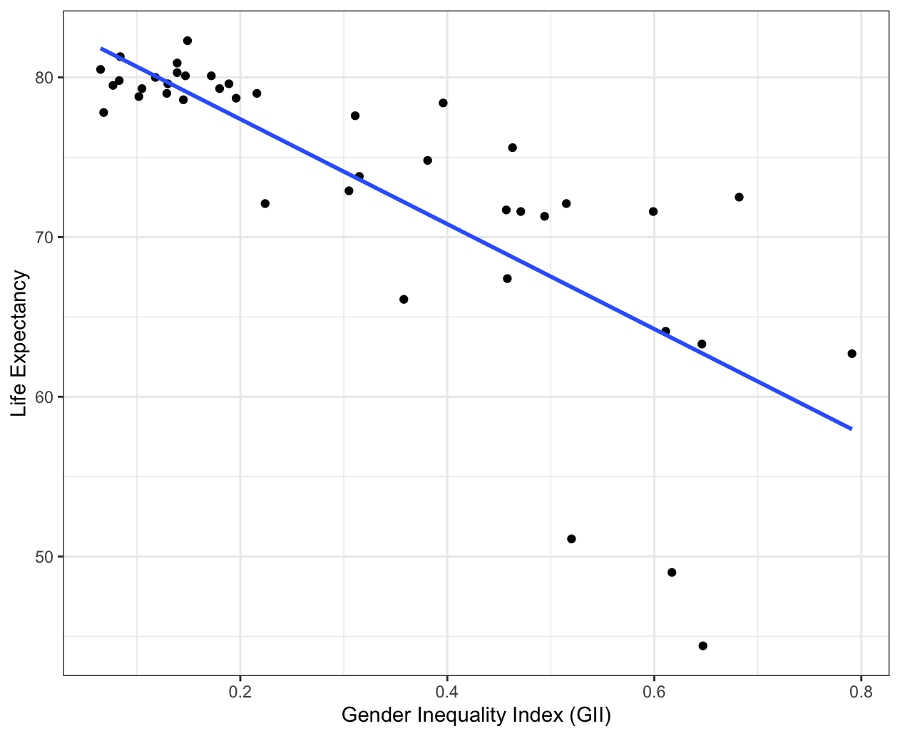
  - Using the scatterplot, describe the relationship between the two variables. You may want to use the correlation between them that you found in Question 1 when describing the strength.
There is a moderately strong, negative, linear relationship between GII and life expectancy with three outliers that have life expectancies below 52.
  - Write down (or type) the regression equation in the context of the problem. Keep at least 2 decimal places for the slope.
$$\hat{Life Expectency}=83.96-32.86(GII)$$
  - Use the predict() function to find the life expectancy for a country that has a GII of 0.5.
predict(country_mod, data.frame(GII = 0.5)) gives a value of 67.53. That is the same as plugging 0.5 in for GII in the model equation in part c.
  - Use the predict() function to find the life expectancy for a country that has a GII of 3.1. Explain why we cannot be confident in that prediction.
predict(country_mod, data.frame(GII = 3.1)) gives a value of -17.91. This prediction doesn’t make sense because you cannot have a country with a negative life expectancy. If we observe the values of GII in our dataset, we see that no value is above 0.8. Plugging in 3.1 is way outside the range of the data and that is not a reasonable thing to do. That is known as extrapolation.
  - Interpret the slope of this regression model in the context of the problem.
The slope is -32.86. This tells us that when the gender inequality index (GII) for a country increases by 1, the predicted life expectancy for a country decreases by 32.86 years.
You could also modify that and say, for instance, when the gender inequality index (GII) for a country increases by 0.1, the predicted life expectancy for a country decreases by 3.286 years.
  - Interpret the intercept of this regression model in the context of the problem.
When the GII is 0, the predicted life expectancy for a country is 83.96 years.
  - According to the output of the model (when you use the summary() function), can we be confident that the true slope is not equal to zero? Explain.
The p-value for the GII variable is 3.44e-09, which is $3.44×{10}^{-9}$. That p-value is very small, which gives us lots of evidence that the alternative hypothesis is true. For this test, the alternative hypothesis is that the true slope is not zero. So, yes, we have strong evidence the true slope of GII is not zero.

  - Use the predict() function to obtain a 95% prediction interval for the life expectancy for any country that has a GII of 0.5. Report the prediction interval and interpret the interval.
predict(country_mod, data.frame(GII = 0.5), interval = "prediction") gives an interval of (55.61, 79.45). We could write it this way: $55.61<y|x=0.5<79.45$.
We are 95% confident that any country that has a GII of 0.7 will have a life expectancy between 48.67 and 73.24 years.
- Now fit a multiple linear regression model using life expectancy as the response variable and GDP, GII, education index, and public health expenditures as explanatory variables.
  - Write down the multiple regression equation in the context of the problem. You can round all slopes to two decimal places except the one for GDP. Keep 7 decimal places for that one.
$$\hat{Life Expectancy}=76.99+0.0003076\left(GDP\right)-23.40\left(GII\right) \\ +4.32\left(EduIndex\right)-1.16(PubHealthExp)$$
  - Use the regression equation (or predict() function) to predict the life expectancy of a country that a GDP of 20,000 per capita, a GII of 0.4, an education index of 0.3, and a public health expenditure measure of 1.8.
predict(county_mod_mult, data.frame(GDP = 20000, GII = 0.4, EduIndex = 0.3, PubHealthExp = 1.8)) gives a value of 72.98.

  - Report and interpret the coefficient of determination for this model.
The coefficient of determination is $R^{2}=0.6467$. This means that 64.67% of the variation in life expectancy is explained by the regression model.
  - Interpret the slope of the education index variable in the context of the problem.
As the education index of a country increases by 1, the predicted life expectancy of the country increases by 4.32 years, holding all other variables constant.
  - Interpret the intercept of this regression model in the context of the problem.
The predicted life expectancy when GDP, GII, Education Index, and Public Health Expenditures all equal zero is 76.88 years.
  - Using a significance level of 0.05, which (if any) variables in this model are not considered significant? Briefly explain how you know.
The only variable that would be considered significant in the model is GII. All other variables, GPD, education index, and public health expenditures are insignificant. We can know that because the p-value for those variables are above 0.05.
  - Use the residual_plots() function in math3150package with resid_type = "raw" to create a residual and QQ plot for this multiple regression model. Comment on what these plots suggest about the regression assumptions here.
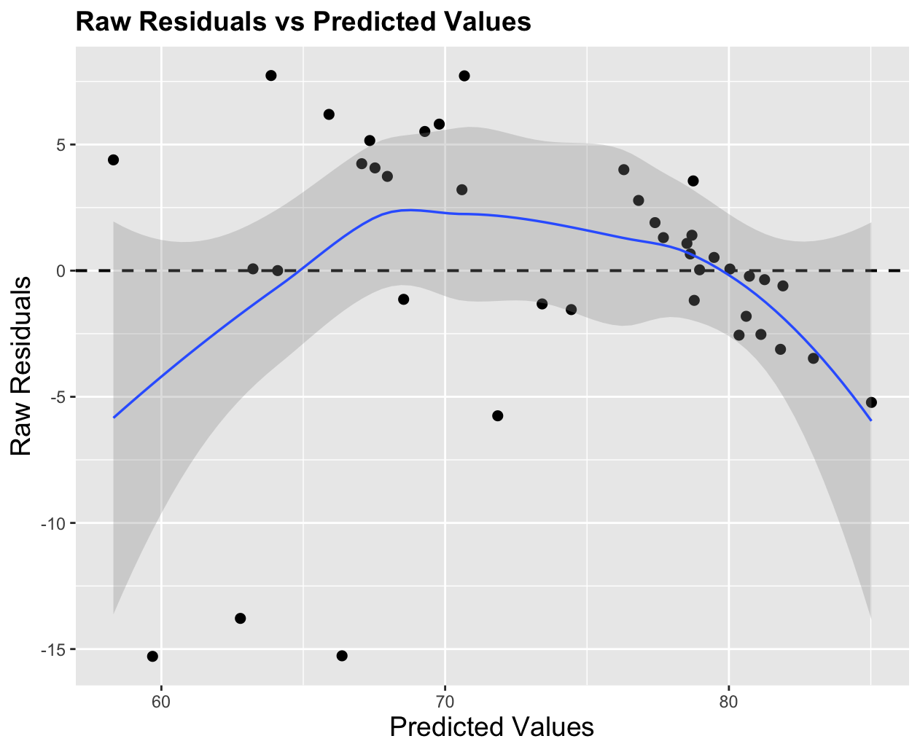 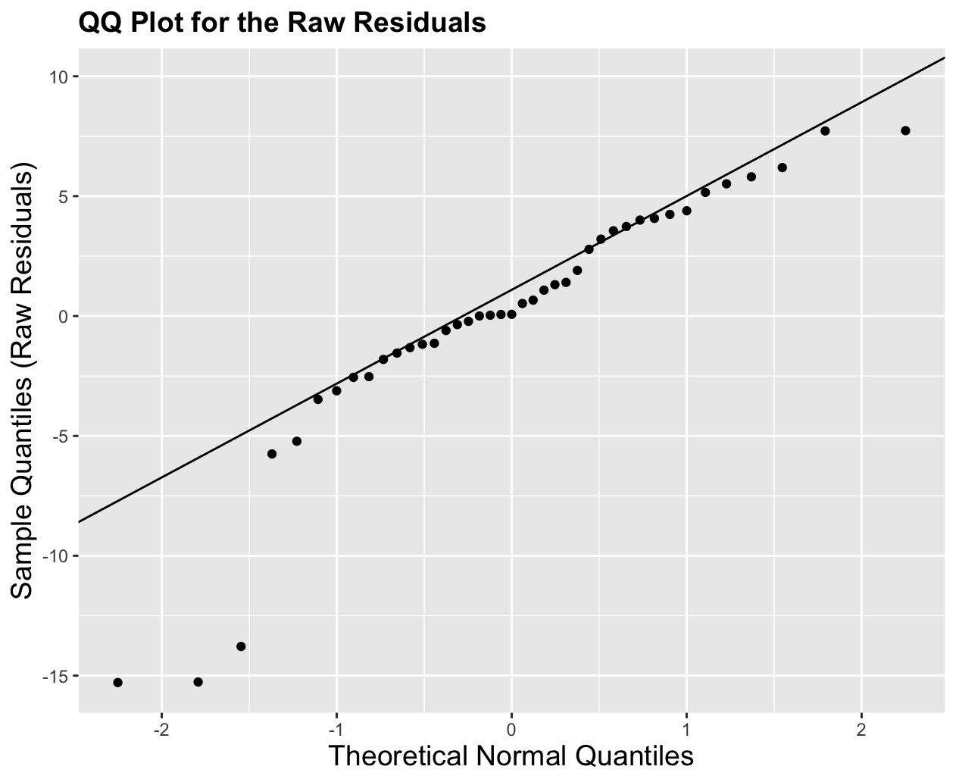
The residual plot is used for checking the linearity and equal variance assumptions.
For linearity, we can see that the residuals have a but if a $∩$ type pattern, which indicates that the linearity assumption may not be met.
Fir equal variance, we can see that the points seem to be closer together on the right side of the plot than the left side, so this assumption may not be met either.
Overall, this is not looking too great, but those 3 outliers on the bottom left may be the problem.
The QQ plot is use for checking the normality assumption. All the points except the three outliers are close to the line, so except for those points the normality assumption looks good. But with those points, we may have some issues.

  - Use the influence_plots() function in math3150package to create influence plots. Looking at Cook’s distance, DfFits, and the DfBetas plots, which points seem to be more influential? What countries are those points?
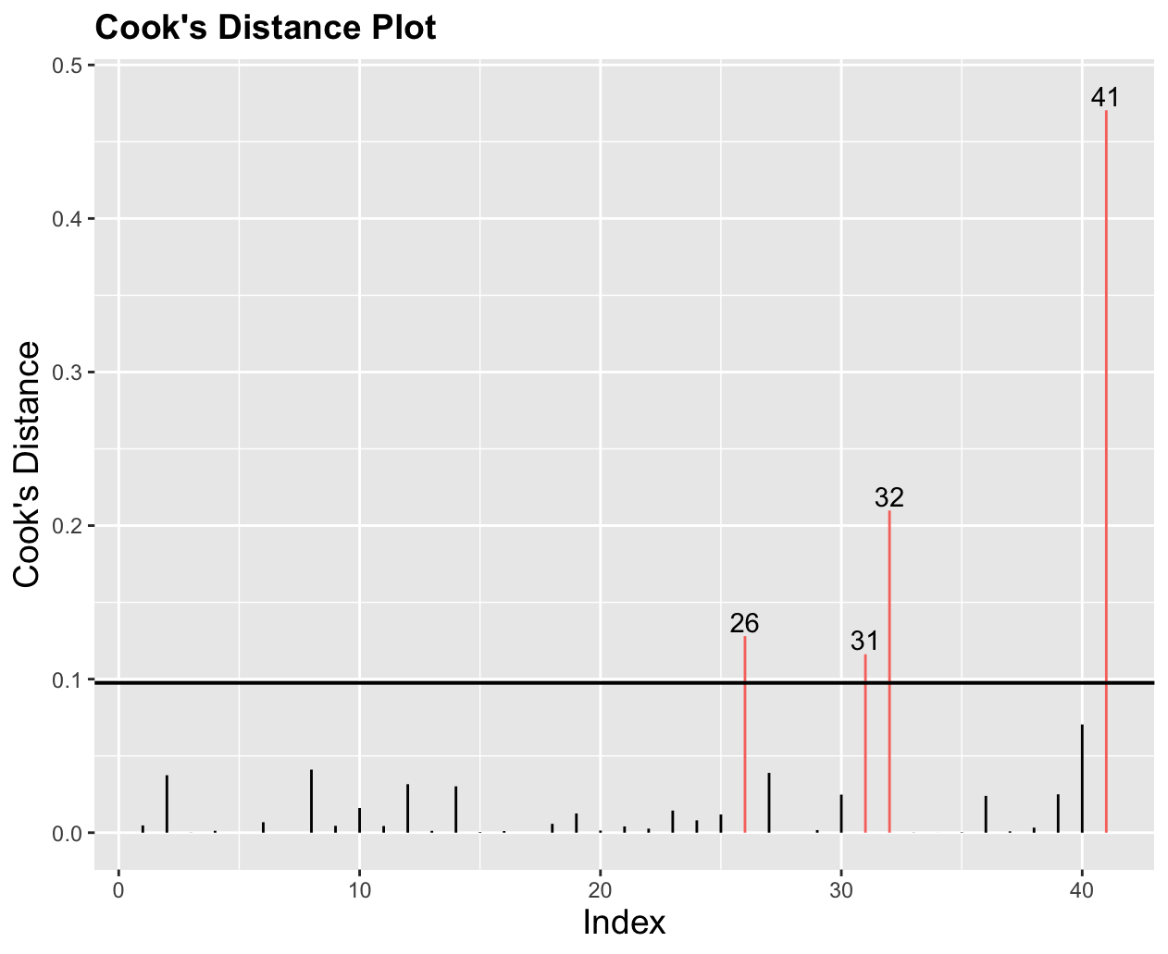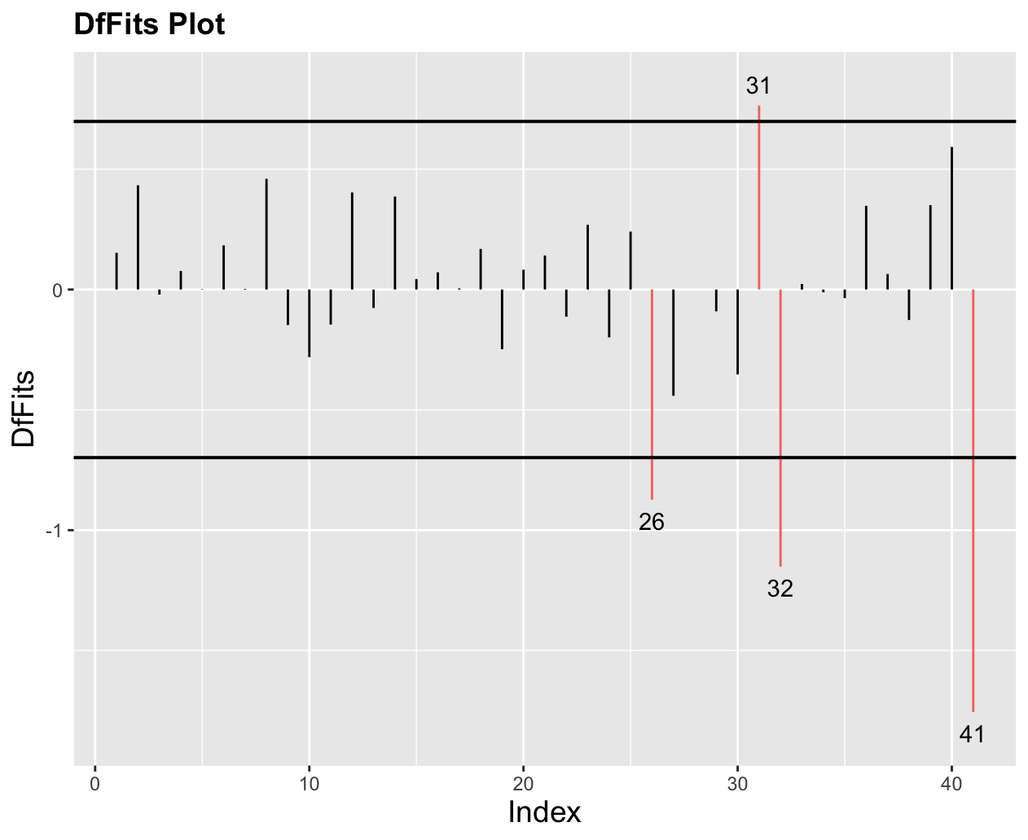
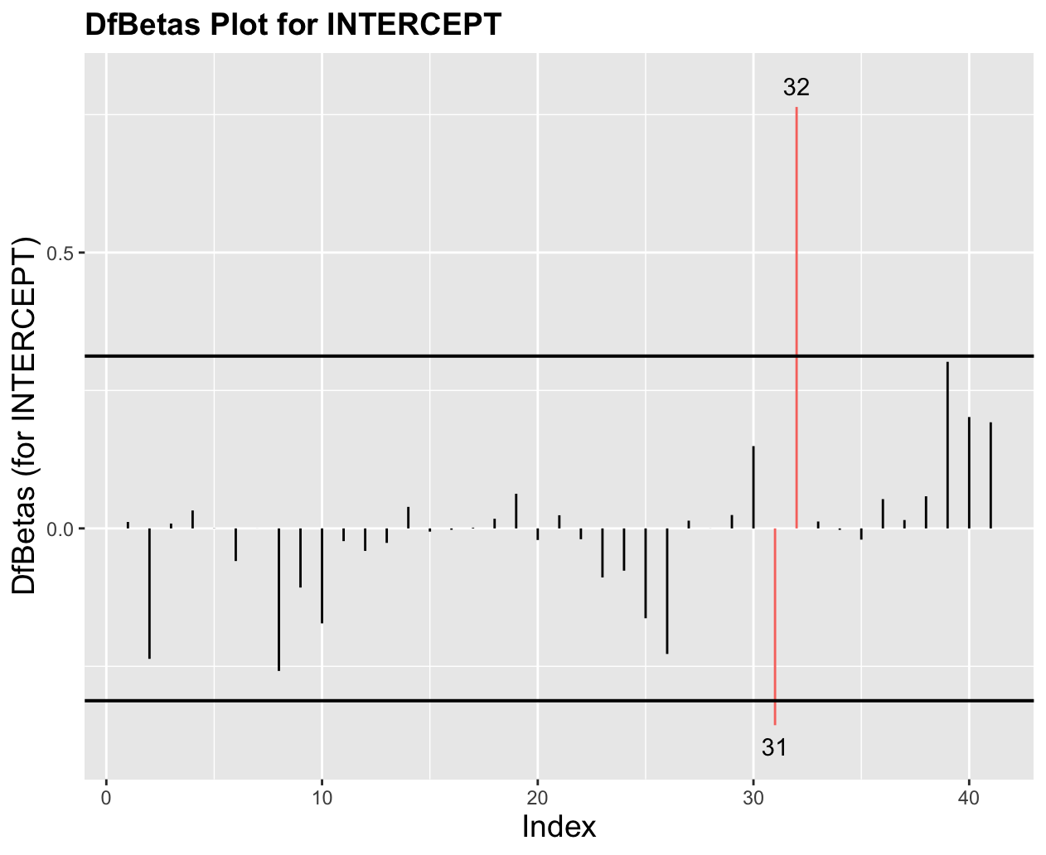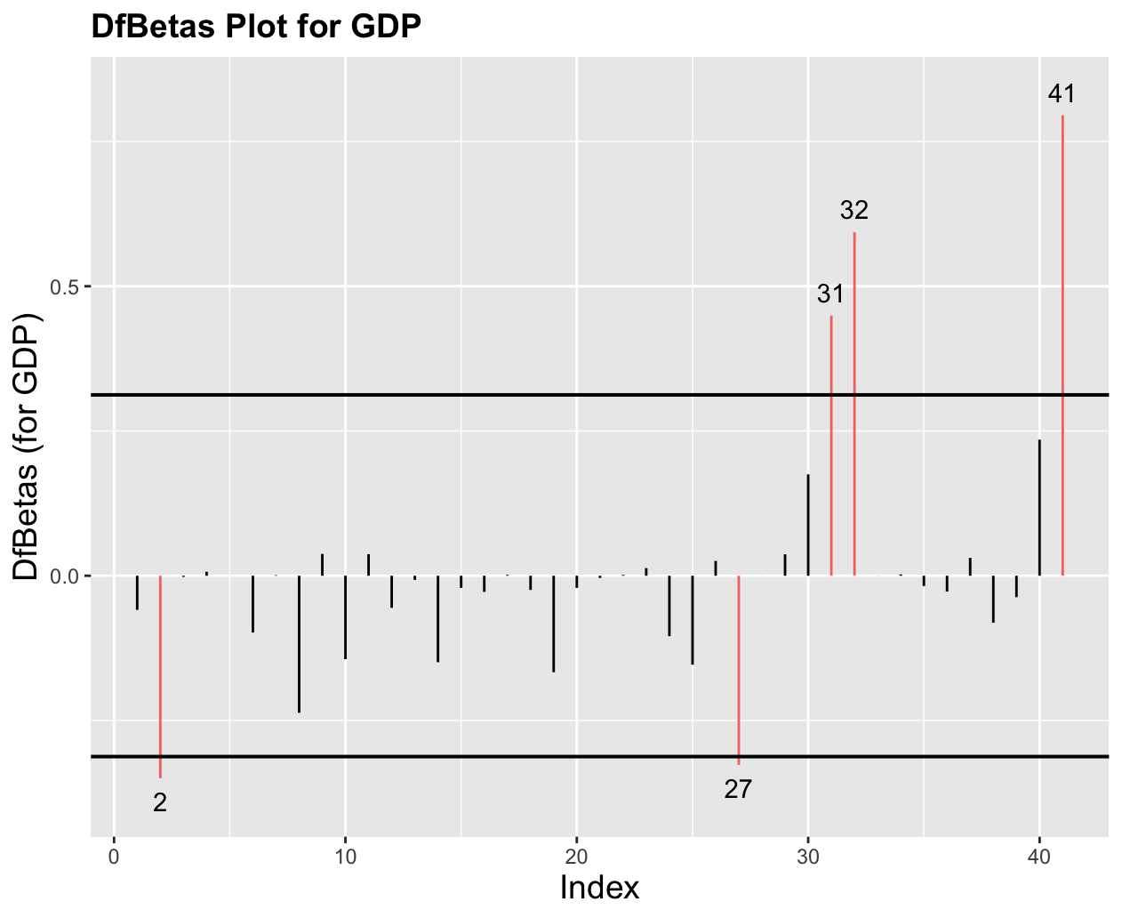
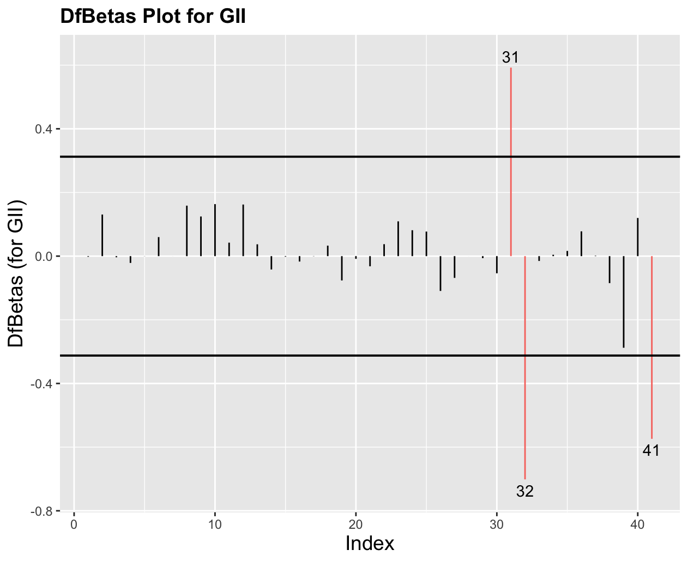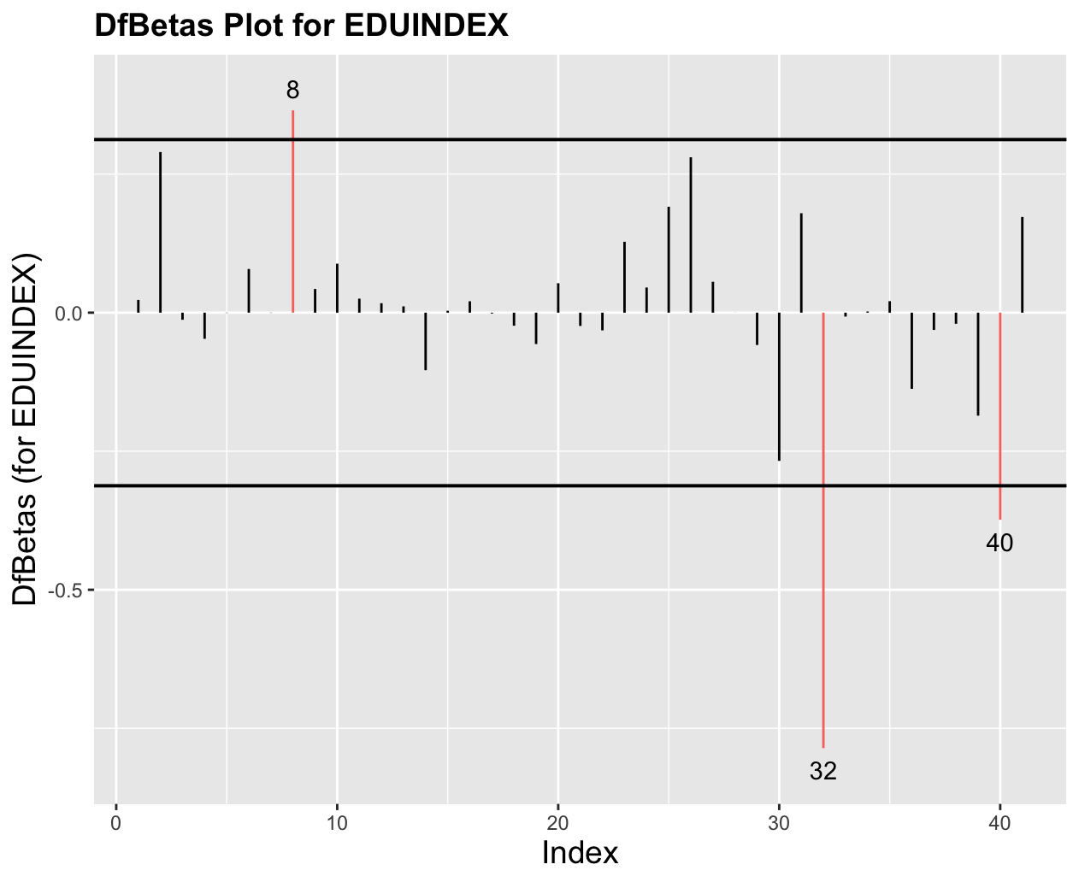
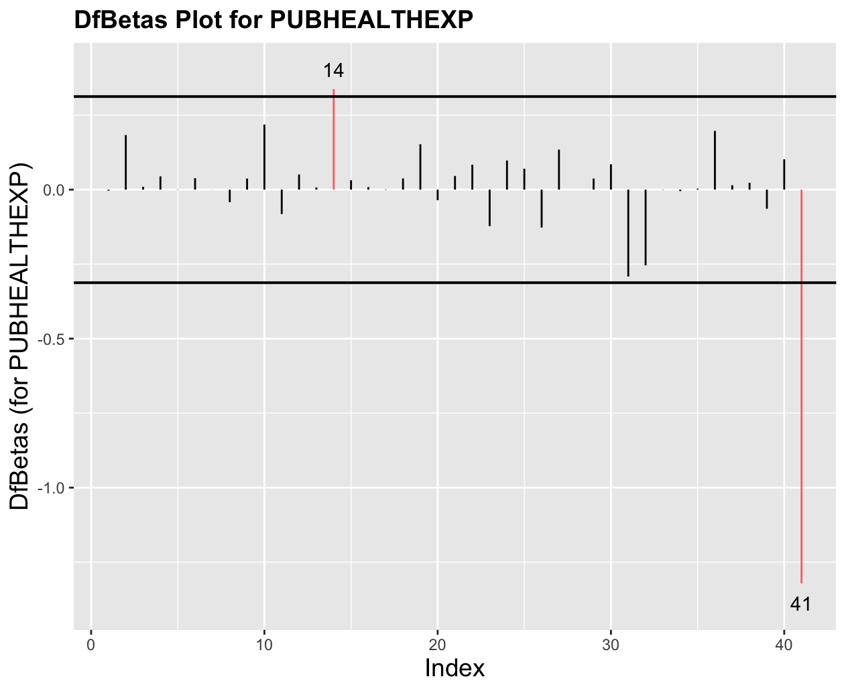
The points that come up in nearly all plots are 26, 31, 32 and 41. 32 and 41 come up the most and often have the largest values. The countries are:
26: Nigeria
31: Saudi Arabia
32: South Africa
41: Zambia.
Out model does not work well for those countries, and especially the three of those in Africa.

